

Windows Installer Instructions

Step 1. Go to either link

File: [popHealth-x86_64.exe](https://xfiles.mitre.org/seos/1000/mpd/1201201235e26aa30bfa0f8f0f6e15100dc3188a), 80,978.70 KB     
File: [popHealth-i386.exe](https://xfiles.mitre.org/seos/1000/mpd/1201201207fec67387d44062d497f595f437d05d), 78,398.88 KB

Step 2: Type in your e-mail and click “Submit” button

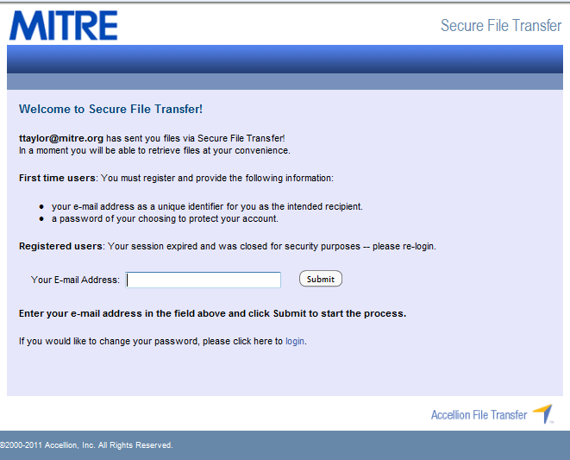

Step 3: Type in your password and click the “Download” button

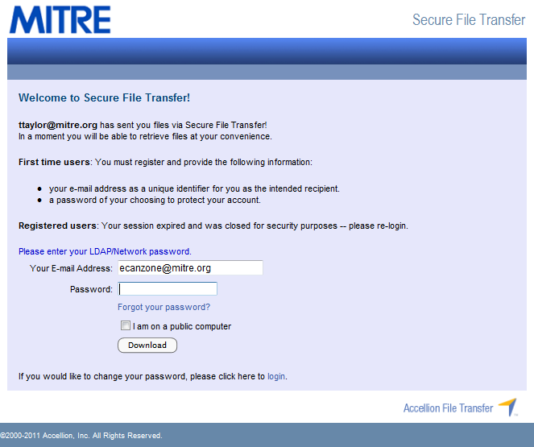

Step 4: Select the appropriate file for your location

Step 5: Click the “Run” button

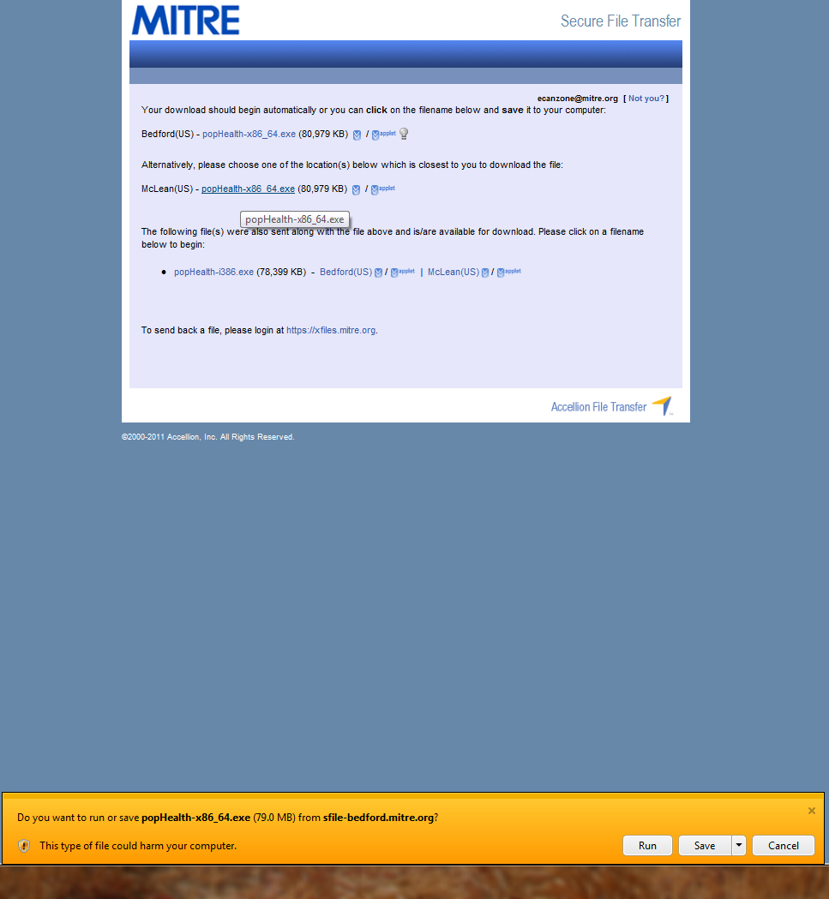

Step 6: Click the “Next” button when the popHealth Setup Wizard opens

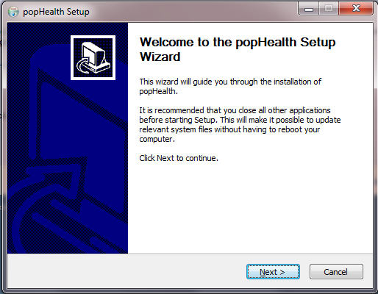

Step 7: Click the check box next to “I accept” and then click the “Next” button

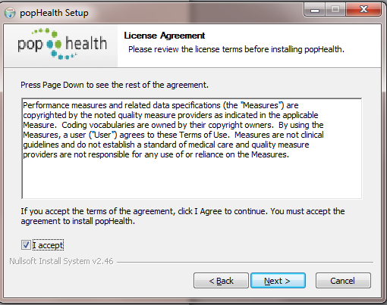

Step 8: Click the “Next” button

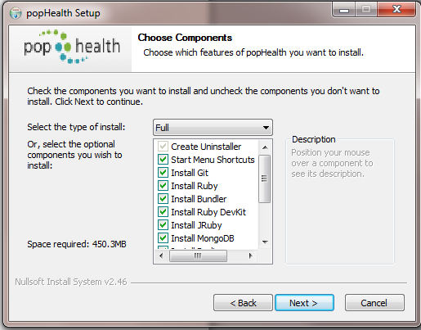

Step 9: Click the “Next” button

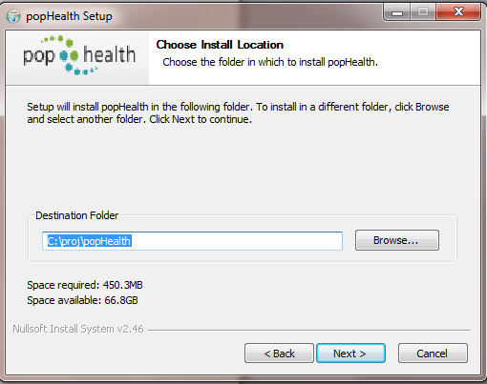

Step 10: Check the “Use Proxy Server” box. Depending on where you are installing the software you will type in the following information:

* MITRE employees in Bedford: type **gatekeeper.mitre.org** in the server text box and **80** in the port text box
* MITRE employees in Washington: type **gatekeeper-w.mitre.org** in the server text box and **80** in the port text box
* If you are installing this else where you will have to get this information from a network administrator.

Then click the “Install” button

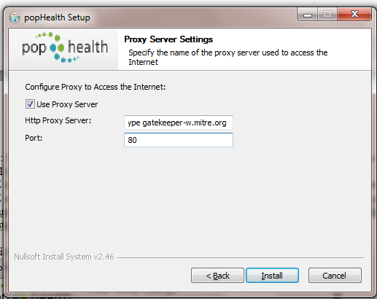

Step 11: IMPORTANT: Note the instructions in the message box and then click the “Ok” button

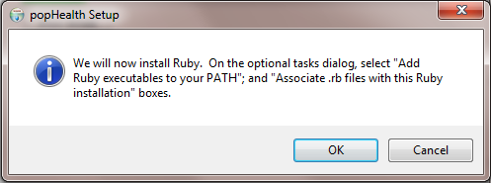

Step 12: Click the check box next to “I accept the License” and then click the “Next” button

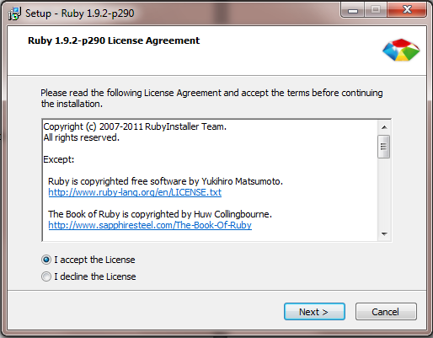

Step 13: Check the boxes next to “Add Ruby executables to your PATH” and “Associate .rb and .rbw files with this Ruby installation” and then click the “Install” button

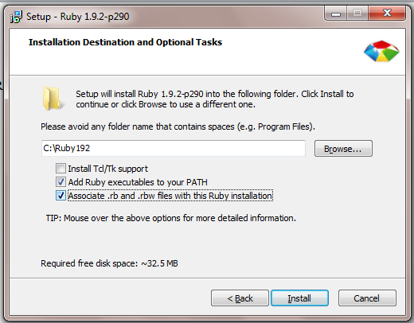

Step 14: Click the “Finish” button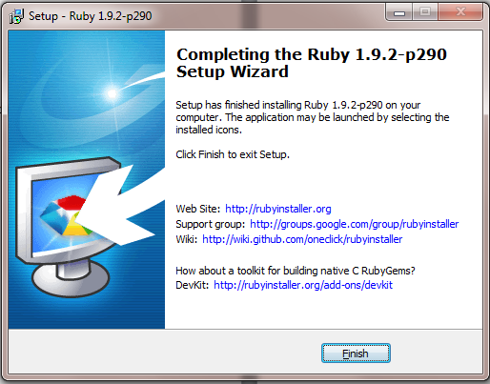

Step 15: Click to either “Reboot now” or Manually reboot later” and then click the “Finish” button

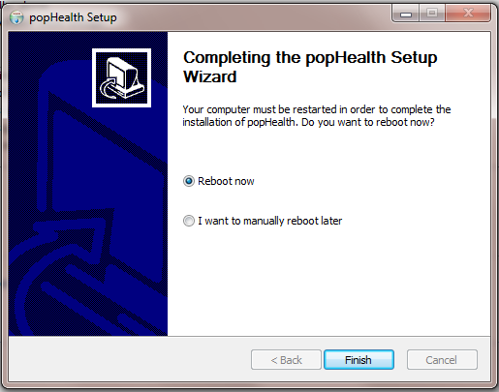

After rebooting your system you can go to the Start Menu and find the popHealth folder. There will be two items in the folder. One is a shortcut to the popHealth login on your web browser.

You can uninstall the program by either selecting the uninstall item in the popHealth folder or by going to the Control Panel, selecting add/remove programs, selecting the popHealth application and then click on the uninstall button at the top of the list of applications.